1.Create a SQL table called Restaurants with columns: id (INT, auto-increment), name (VARCHAR), cuisine (VARCHAR), rating (DECIMAL), and city (VARCHAR). Insert 5 sample restaurants into the table, each with a different cuisine and rating.
ANS:
Query:
CREATE TABLE Restaurants (
id INT AUTO_INCREMENT PRIMARY KEY,
name VARCHAR(100),
cuisine VARCHAR(200),
rating DECIMAL(2,1),
city VARCHAR(300)
);
INSERT INTO Restaurants (name, cuisine, rating, city)
VALUES
('Spice Villa', 'Indian', 4.5, 'Lajpor'),
('Pizza Hunt', 'Italian', 4.1, 'Ahmedabad'),
('Chinese Wokk', 'Chinese', 3.5, 'Surat'),
('Burger Point', 'Mexican', 3.2, 'Mumbai'),
('Macdonald', 'American', 4.6, 'Ahmedabad')
SELECT * FROM `restaurants` WHERE 1;
Output:
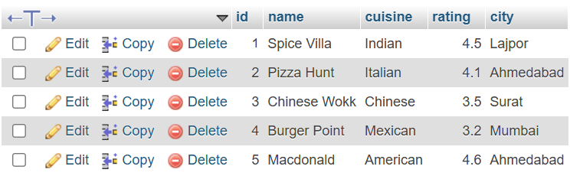
Q.2. Write a SQL UPDATE statement to change the rating of the restaurant named 'Spice Villa' to 4.7 in the Restaurants table.
ANS:
Query:
UPDATE restaurants set rating=4.7 WHERE name = 'Spice Villa';
SELECT * FROM restaurants;
Output:
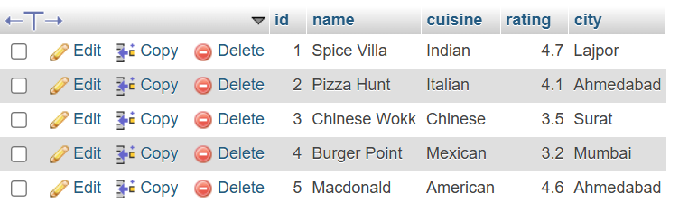
Q.3. Delete all restaurants from the Restaurants table where the rating is less than 3.5 using a SQL DELETE statement.
ANS;
Query:
DELETE FROM restaurants WHERE rating < 3.5;
SELECT * FROM restaurants;
Output:
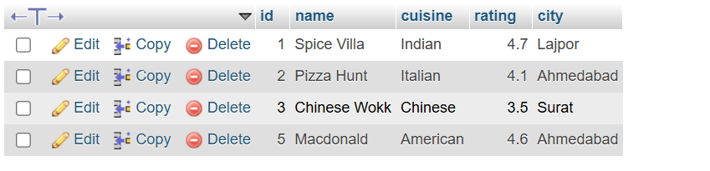
Q.4. Use a SELECT query with WHERE and LIMIT to fetch the top 2 restaurants in the city 'Ahmedabad' with a rating above 4.0 from the Restaurants table.
ANS:
QUERY:
SELECT * FROM restaurants WHERE city= 'Ahmedabad' AND rating > 4.0 ORDER BY rating DESC LIMIT 2;
Output:
